Lesson 13: How (and why) does the structure of a cushioning material affect the peak forces produced in a collision?

Previous Lesson | We conducted an investigation to determine what materials reduce peak force in a collision. We compared the materials and found similarities in their structures. We determined peak force is reduced equally on both objects, regardless of size. We tried to develop a model to explain how the materials function to help reduce peak forces.
This Lesson  Investigation  3 days   | 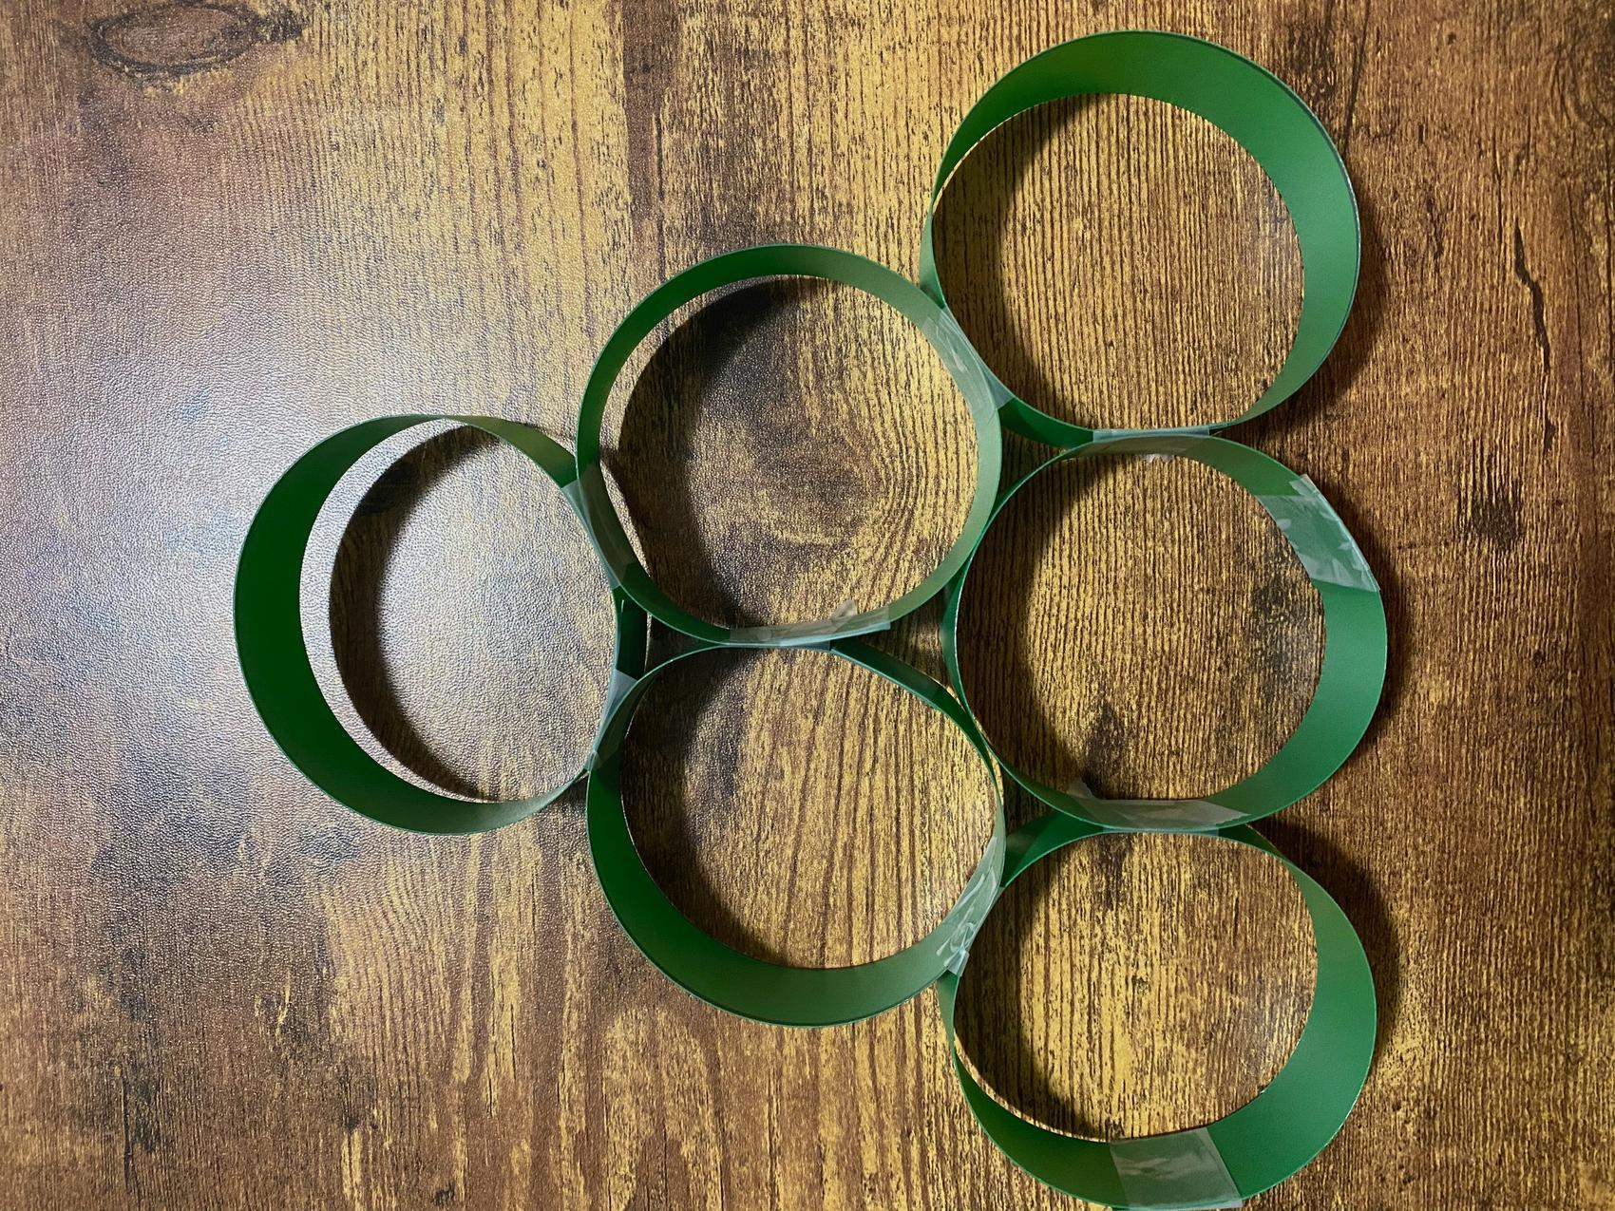 | We develop a model to represent how the structures of materials compare in the top four performers for peak force reduction. We use scaled-up versions of these structures to generate data using slow-motion video about the unobservable mechanisms at work in the system. We carry out an investigation to determine how the amount of force applied to different points of a cushioning structure is affected by the shape of that structure.
Next Lesson | We will redesign our device using our science ideas. We will share our redesigns with stakeholders to get feedback and will use the feedback to evaluate the potential design materials. We will reflect on the consequences of those potential changes based upon stakeholder feedback.

BUILDING TOWARD NGSS  MS-PS2-1, MS-PS2-2, MS-PS3-1, MS-ETS1-2, MS-ETS1-3, MS-LS1-8   | What students will do  13.A Construct an explanation for how (and why) the structure of a cushioning material affects the peak forces produced (function) in a collision, relating the amount of space available for deformation, the total contact time during a collision, and the peak forces produced from the addition of such structures.  13.B Develop and use subsystem models (free body diagrams) to represent how the peak contact forces on different objects in a collision compare when they have different cushioning structures between them.  13.C Critically read a scientific text adapted for classroom use to determine how concussions can result in breaks in the axons of neurons (structure) and why this can lead to memory loss (function), how a snug fit (structure) for a helmet would affect its performance (function), and how other changes in the structure of cushioning material (in a helmet) would affect its performance (function).  What students will figure out  - Protective materials tend to have a lot of space (or air) for the solid materials to deform into, which makes these materials relatively easy to deform (with little force applied to them).  - The thicker these kinds of materials are, the more they reduce peak forces because this increases the total time the collision takes.  - Making a material more densely packed with smaller and smaller spaces does not necessarily reduce peak forces; such increased density may actually have the opposite effect.  - The more you can spread the peak forces out over a larger area or over more points of contact, the less force is applied to each point of contact; this can reduce the amount of damage on the material you are trying to protect.

Lesson 13 • Learning Plan Snapshot
Part | Duration |  | Summary | Slide | Materials
1 | 5 min |  | NAVIGATION  Turn and talk about the properties of materials identified in Lesson 12. | A
2 | 12 min |  | DEVELOP AND USE A MODEL  Develop a diagrammatic model for representing small and microscopic structures in cushioning materials and develop a physical model of these to use to test the behavior of structures in a collision. | B | Smaller-Scale Material Structures poster, markers, 1 roll of transparent tape, 8-12 trimmed sheets of paper to fit in each cell on the poster, 2 rectangular strips (1” x 9.25” each) of material cut from a plastic folder cover
3 | 4 min |  | PREDICT OUTCOMES AND PLAN FOR DATA COLLECTION  Make predictions on how adding the rings between two colliding objects would affect the forces between them and set up data collection tables. | C | half-sheet data table from Observations from Adding Additional Ring Structures
4 | 10 min |  | RECORD AND ANALYZE DATA FROM SLOW-MOTION VIDEOS  Record data from five slow-motion videos for the five collision conditions. Analyze and interpret the data in the whole group. | D | Observations from Adding Additional Ring Structures, computer, projector, https://youtu.be/co5fN22N50A, https://youtu.be/OU0LsRFmBnk, https://youtu.be/3A1gKY2qK1U, https://youtu.be/eqKLBJFZlnE, https://youtu.be/nqaDgidCHOM
5 | 10 min |  | ANALYZE AND INTERPRET THE DATA FROM THE VIDEOS  Analyze and interpret the patterns in data from the five slow-motion videos as a whole class. | E
6 | 5 min |  | INDIVIDUAL PROGRESS TRACKER | F

End of day 1
7 | 20 min |  | DEVELOP AND USE FREE BODY DIAGRAMS  Develop free body diagrams to represent the forces between the subsystem structures and between those structures and a cushioning material. | G | Free body diagrams for collisions with and without cushioning structures, 2 colored pencils (any color), Consensus model from Lesson 5 with the free body diagram on it, chart paper, markers
8 | 6 min |  | USE FREE BODY DIAGRAM MODELS TO MAKE PREDICTIONS  Create a series of free body diagrams to show how the relative strength of the peak forces on each subsystem in a collision with three rings in the cushioner in the system would compare to the other conditions. | H | Free body diagrams for collisions with and without cushioning structures
9 | 4 min |  | SIZE PREDICTIONS  Consider a system where there is a limited amount of total space available for adding cushioning material to it. | I | Free body diagrams for collisions with and without cushioning structures
10 | 7 min |  | ANALYZE SIZE DATA AND UPDATE PROGRESS TRACKER  Add to the Progress Tracker how and why the structure of different cushioning materials affects peak forces in a collision. | J
11 | 3 min |  | NAVIGATION  Make predictions about changes to the structure or shape of a cushioning material and the related effect on peak forces in a collision. | K

End of day 2
12 | 3 min |  | NAVIGATION  Discuss reasons for predictions about how changing the structure of cushioning material will affect peak forces in a collision. | L
13 | 5 min |  | INTRODUCE A CONTROL CONDITION AND MAKE PREDICTIONS | M | Exploring shape of a cushioning material, Other Shape Tests
14 | 10 min |  | TEST THE FIRST THREE STRUCTURES |  | Exploring shape of a cushioning material, Other Shape Tests
15 | 5 min |  | TEST THE LAST TWO STRUCTURES |  | Exploring shape of a cushioning material, Other Shape Tests
16 | 18 min |  | PROGRESS TRACKER UPDATE  Update individual Progress Trackers and use these entries to contribute to a class discussion to add a whole class Progress Tracker update. | N | chart paper, markers
17 | 5 min |  | NAVIGATION  Consider how we could apply our ideas to the design of a protective headgear for preventing concussions in sports-related collisions and how we might apply what we figured out to our own design problems. | O-P | Reading: Anatomy of a Bike Helmet

End of day 3

Lesson 13 • Materials List
 | per student | per group | per class
Other Shape Tests materials | - safety goggles |  | - 5 weighted plates (washers secured to the plate with sticky putty and a dime-size piece of sticky putty secured to the other side)  - 5 preassembled ring structures  - 1 digital scale  - 5 weighted plates (washers secured to the plate with sticky putty  - and a dime-size piece of sticky putty secured to the other side)  - 1 piece of 8” x 11” x ½” Styrofoam panel per class (consumable)  - 3 5-N push-pull spring scales  - 1 fine-tip permanent marker  - 3 weighted plates (washers secured to the plate with sticky putty
Lesson materials | - half-sheet data table from Observations from Adding Additional Ring Structures  - science notebook  - Observations from Adding Additional Ring Structures  - Free body diagrams for collisions with and without cushioning structures  - 2 colored pencils (any color)  - Exploring shape of a cushioning material  - Reading: Anatomy of a Bike Helmet |  | - Smaller-Scale Material Structures poster  - markers  - 1 roll of transparent tape  - 8-12 trimmed sheets of paper to fit in each cell on the poster  - 2 rectangular strips (1” x 9.25” each) of material cut from a plastic folder cover  - computer  - projector  - https://youtu.be/co5fN22N50A  - https://youtu.be/OU0LsRFmBnk  - https://youtu.be/3A1gKY2qK1U  - https://youtu.be/eqKLBJFZlnE  - https://youtu.be/nqaDgidCHOM  - Consensus model from Lesson 5 with the free body diagram on it  - chart paper

Materials preparation (60 minutes minutes)

Review teacher guide, slides, and teacher references or keys (if applicable).

Make copies of handouts and ensure sufficient copies of student references, readings, and procedures are available.

Look back at student work turned in from Lesson 10. Identify areas of controversy over how the materials work to make connections to in this lesson

Make 1 copy of Observations from Adding Additional Ring Structures per two students. There are two data tables on this, so cut the copies in half so that you have one half sheet (one data table) per student.

Prepare an Smaller-Scale Material Structures poster for the top four peak force reduction materials for your classes. The example shown here has space for the top six peak force reduction materials, rather than only your top four.

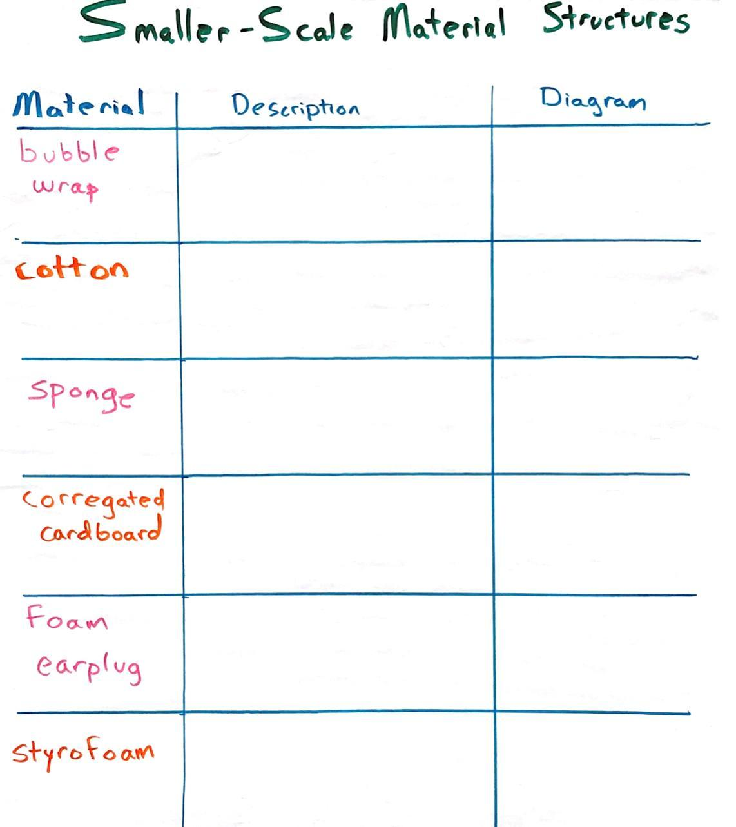

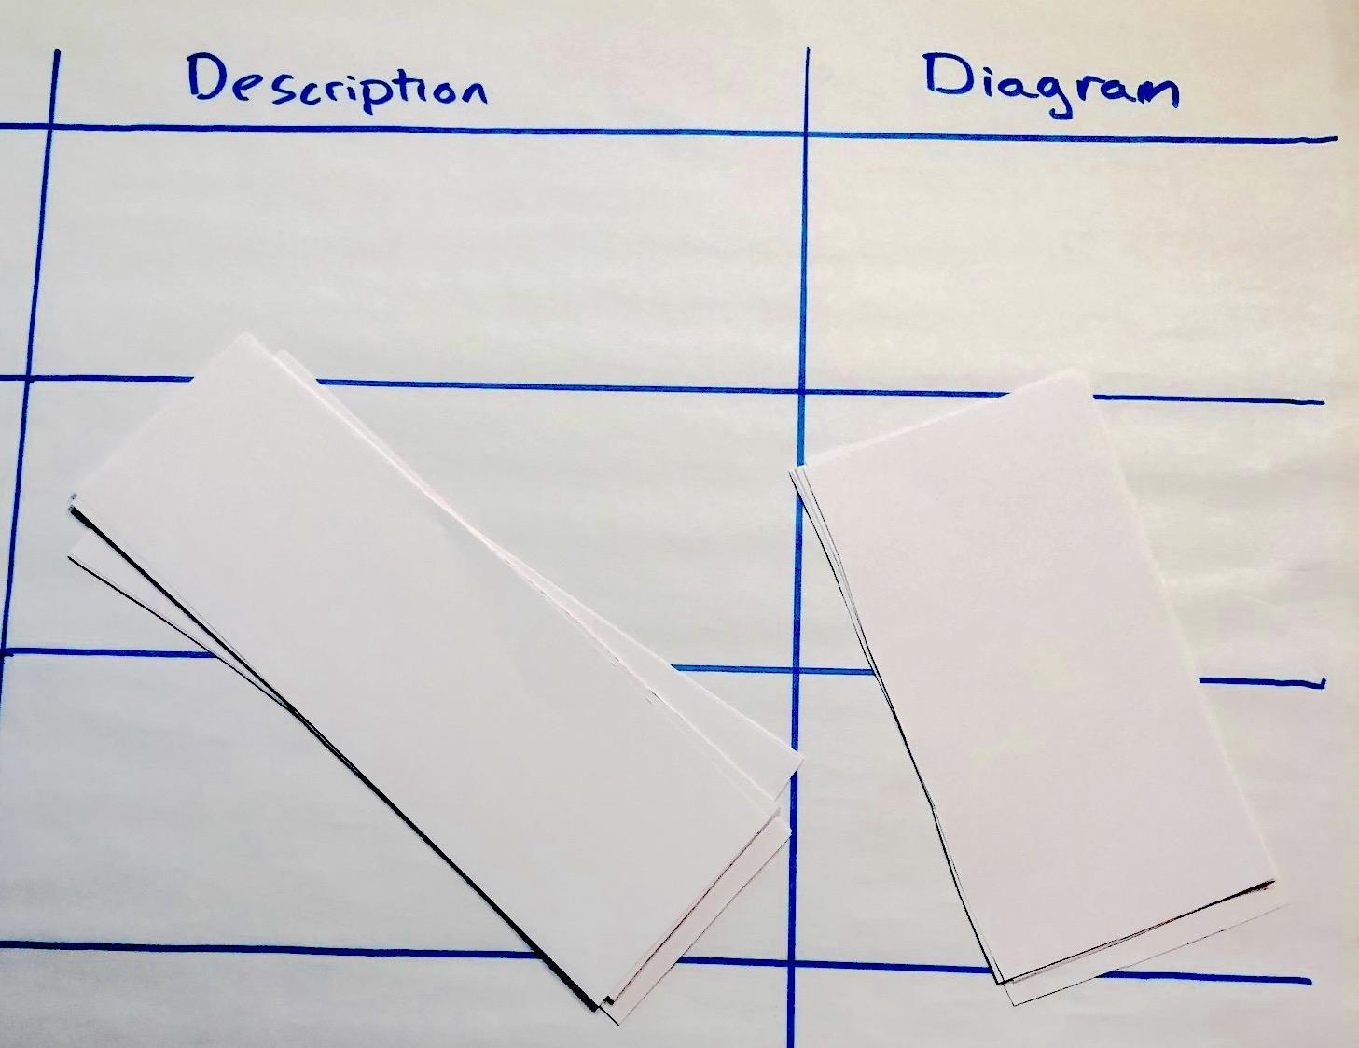
Cut pieces of copy paper so that you have enough to fit in each cell of this table for each class. This will allow you to co-construct the representations with each class during the related discussion.
You will remove the half sheets of paper between classes so that you can reuse the poster between classes.

The completed cells are shown below. Ideally you co-construct each of these with each new. It can be helpful to have one set of these prebuilt, however in case you need to use those if time is short.Keep the final class’s representations posted in the classroom as an anchor chart for students to refer to in the remaining lessons of the unit.

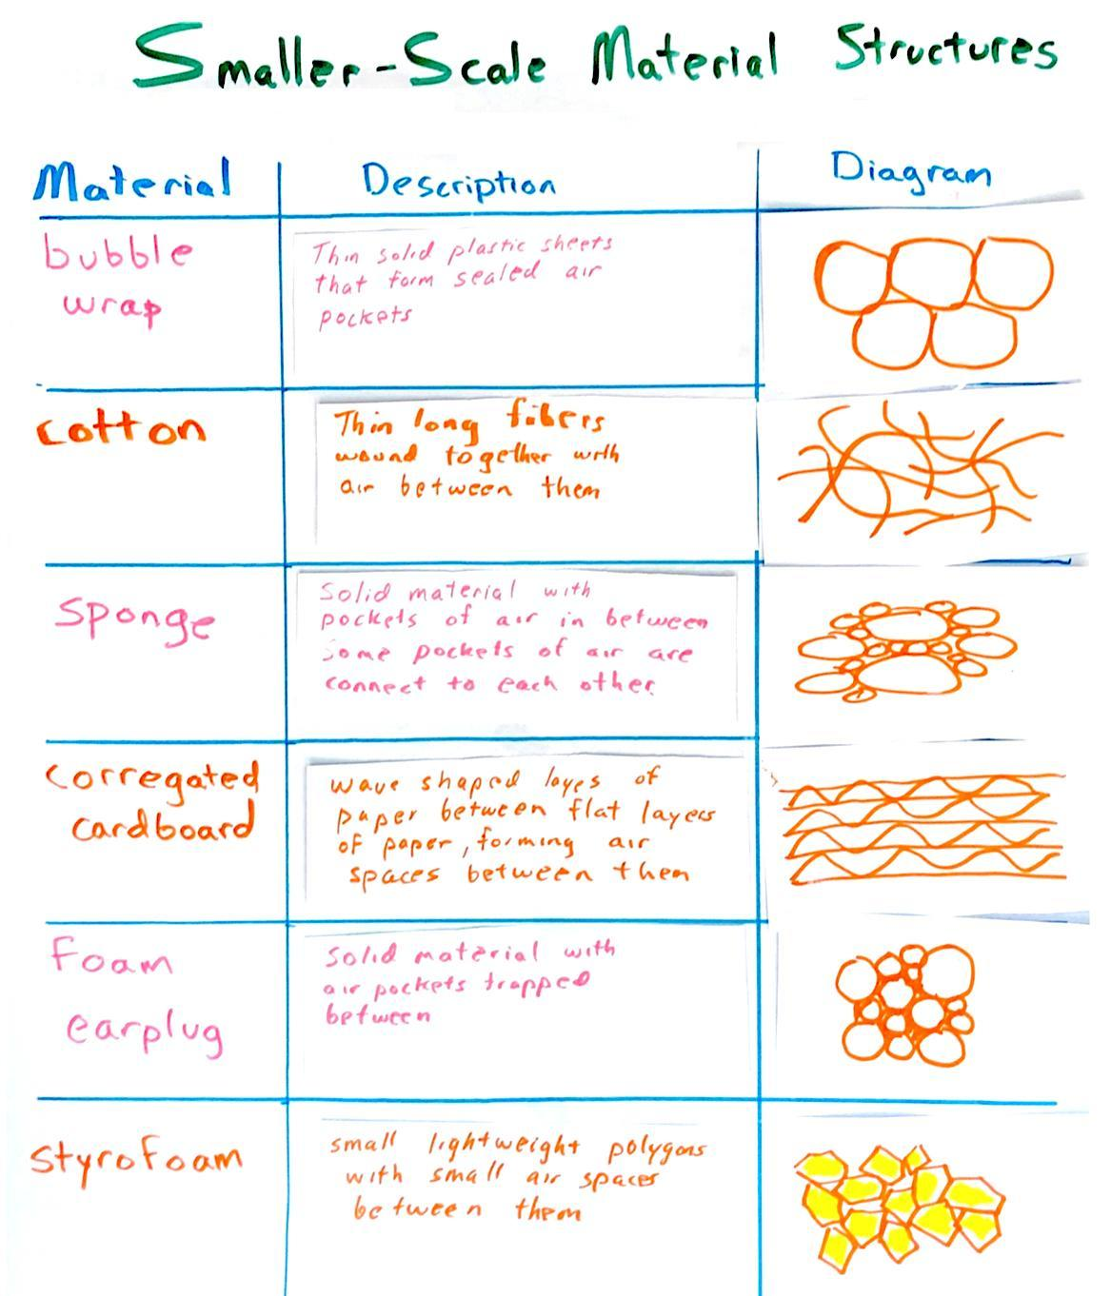

Prepare an Smaller-Scale Observations from Adding Additional Ring Structures poster for the top four peak force reduction materials for your classes. The example shown here has space for the top six peak force reduction materials, rather than only your top four.

Put the consensus model that you made from Lesson 5 with the free body diagrams on it in a place that you can reference it later in the lesson.
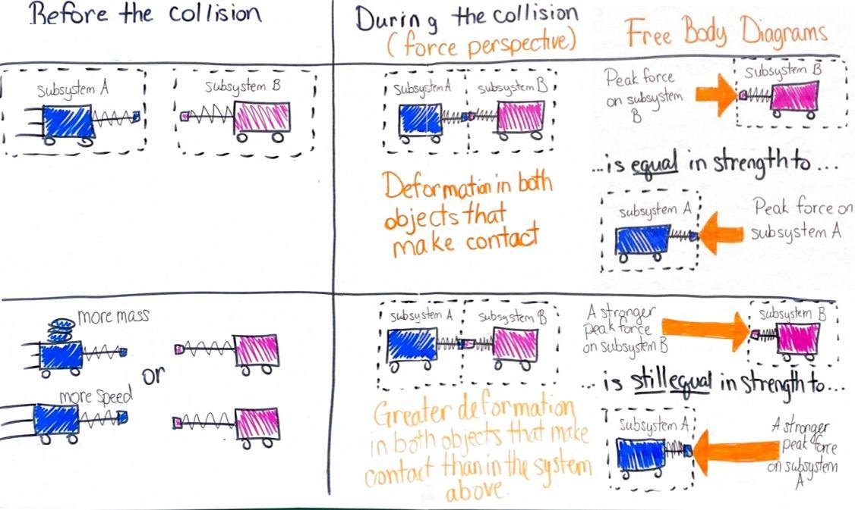

Day 3: Other Shape Tests lab
- Group size: Whole class
- Setup: Set aside 1 piece of 8” x 11” x ½” Styrofoam panel per class (consumable). Set aside 3 5-N push-pull spring scales, 1 digital scale, and 1 fine-tip permanent marker to reuse across all classes.
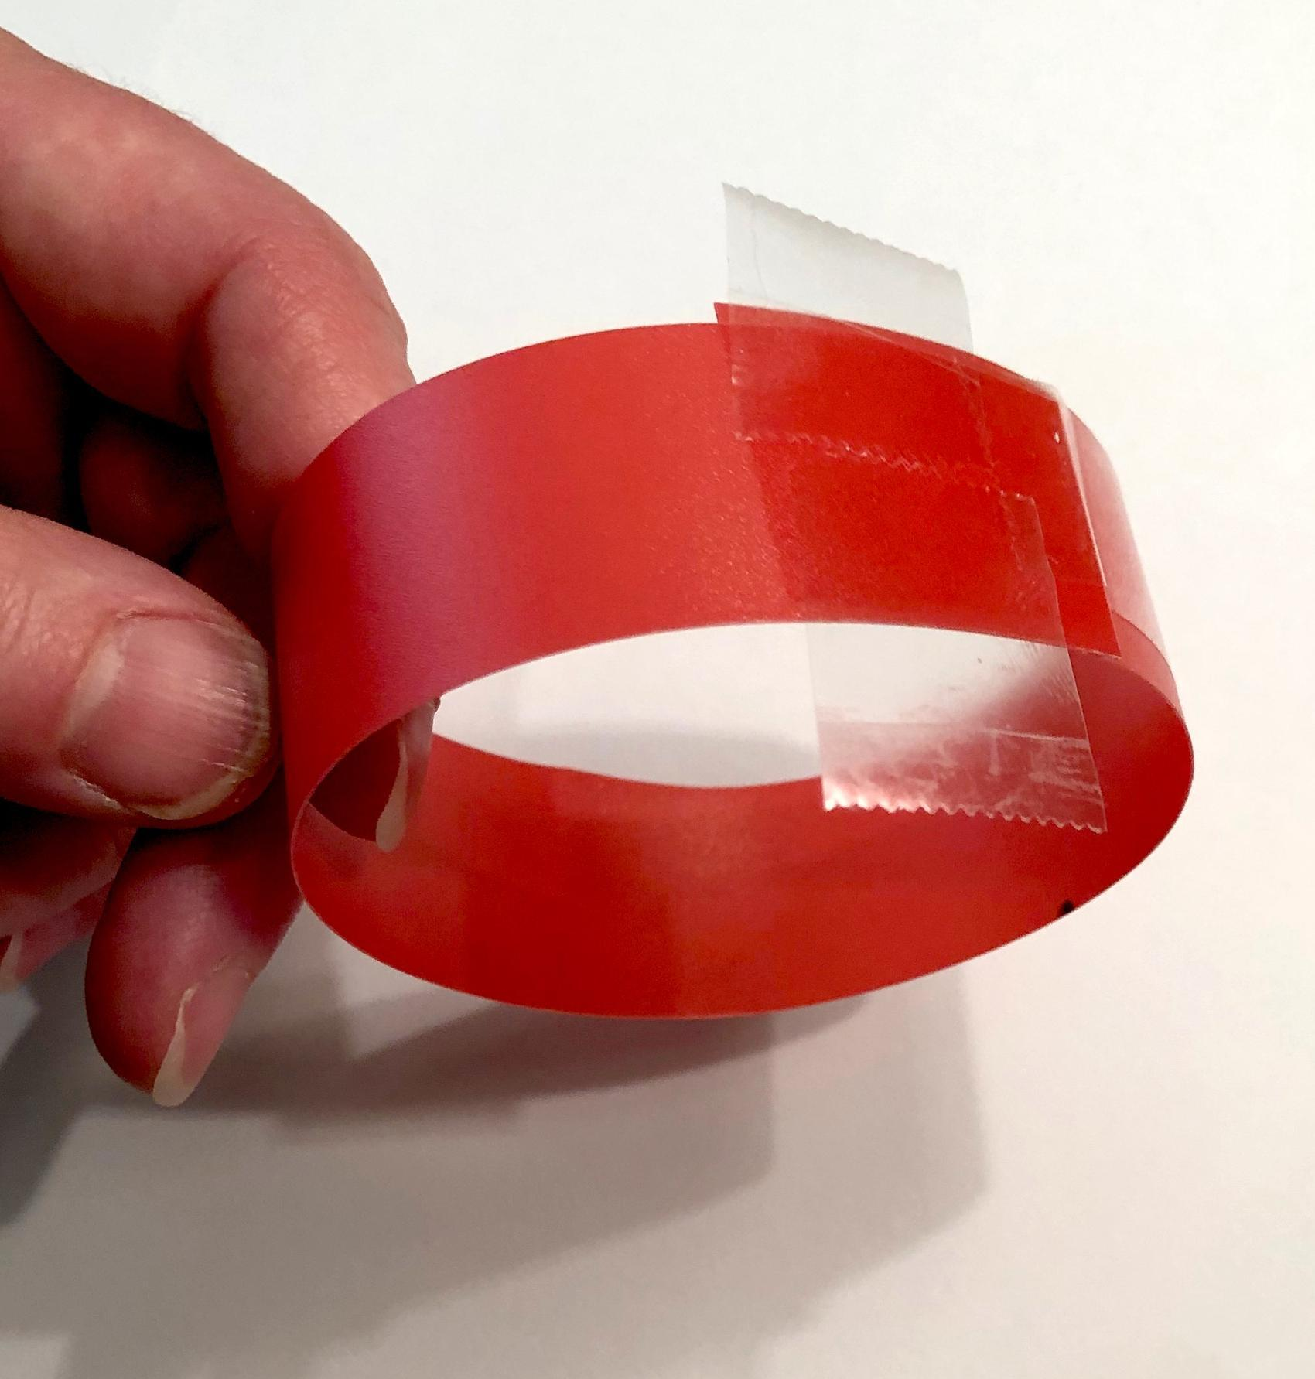
- Preparation of ring structures (The complete set of 5 pre assembled ring structures will be two 6-ring triangles, one 3-ring structure, one 2-ring structure, and one single ring.)
- Cut out 20 strips from a plastic folder cover, each 1 inch wide and 9.25 inches long.
- Leave 2 strips unmodified for demonstration purposes later to show how a ring is made from a strip.
- Roll each remaining strip (18 total) into a ring, overlap the ends of the strip 0.5 inches, and tape the inside and outside of it with a 3-inch piece of tape.
- You will now have 18 rings roughly 2.75 inches in diameter.
- Make 3 sets of these: Place two rings side by side and tape them together along the edges where they meet. Use 2 half-inch pieces of tape to do this.
- Make 3 sets of these: Place three rings side by side and tape them together along the edges where they meet. Use 4 half-inch pieces of tape to do this.
- Now build two triangles using a set of 3 rings, a set of 2 rings, and a single ring for each triangle. Use half-inch pieces of tape to tape them together along the edges where they meet. Your completed ring triangle structures will look like this:

- Preparation of weighted plates: Make 3 weighted plates, 200 grams each. Do the following for each plate:
- Attach two large washers to one side of a plastic electrical cover using a dime-sized piece of sticky putty.
- Place a dime-sized piece of sticky putty on the other side of the plate too to use later for sticking the rings to.
- Mass the system on a digital scale.
- Adjust the amount of sticky putty on each plate setup so that every weighted plate you make has the same amount of mass on it.
- Safety
- Wear safety goggles or glasses during the setup, hands-on, and take-down segments of the activity.
- Carts can fall off the tables if a brick is not placed at the end of the track. Make sure each station has a brick at the end of the track.
- Bricks are heavy and can cause injury when dropped on body parts. Make sure all bricks are away from edges of tables or areas where there is a drop risk.
- Make sure all fragile items are removed from the test area.
- Secure loose clothing, remove loose jewelry, wear closed-toe shoes, and tie back long hair.
- Immediately pick up any items dropped on the floor so they do not become a slip or fall hazard.
- Storage
- Dispose of the damaged Styrofoam panel. All other materials can be stored and reused indefinitely.

Lesson 13 • Where We Are Going and NOT Going

Where We Are Going

Three different relationships related to how the structure of a cushioner can affect its function are introduced in this lesson in order to give students a variety of competing trade-offs to consider in their own designs:
- Thicker cushioning materials should reduce peak forces more.
- The structure of such cushioning materials can be changed at a microscopic and/or a macroscopic level, and both changes may impact the peak forces in a collision.
- The shape of a structure can distribute contact forces over a smaller or larger area, thereby increasing or reducing the amount of peak force on a specific section of material.

This latter idea expands the definition of breaking point, which up until now has been defined as the amount of peak force an object can withstand before reaching its elastic limit. While that is true for fixed-volume or fixed-shape samples of a material, engineers typically determine breaking points by comparing the amount of stress, or force per unit area, between different materials in relation to the amount of deformation the samples undergo. This allows them to make comparisons more easily between material samples with different cross-sectional areas.

This lesson advances students’ work in systems and system modeling by engaging them in developing free body diagrams for a multi-object system undergoing contact force interactions (more than two objects in the system), and it gives them an opportunity to define the number of subsystems they will treat a chain of 3 rings as when they build these diagrams.

It also advances their understanding of the role of models in engineering related to the role of physical scale models that are often constructed to understand physical systems better and to generate data to use to guide engineering solutions. Students worked with examples of this in OpenSciEd Unit 6.5: Where do natural hazards happen and how do we prepare for them?(Tsunami Unit), where models were used to scale down phenomena that were too large to see (tsunami formation and propagation and design solutions for protecting vulnerable coastlines). But the work in this unit helps them understand that such scale models can also be used to scale up smaller-scale phenomena. In particular, students are introduced to the idea that working with larger-scale analogs of microscopic structures could help them understand what might be happening at a much smaller scale within the microscopic structures of our top force-reducing materials. They are told that this is something that engineers and scientists often do when they want to understand how something works at a scale that is too small to see. They develop larger-scale models and test how those work and use the results of these tests to better understand the unobservable changes occurring in those smaller structures.

Students develop a line of evidence that explains how cushioners work by relating the amount of space available in microscopic structures within cushioning material for those structures to be able to deform in a collision, the amount of peak force they produce, and the total amount of contact time during the collision. This leads them to establish a generalized statement of the relationship among net forces applied to an object, the time those forces are applied, and the amount of change in motion. The form of the statement “When weaker forces are applied to an object it will take more time to change its motion” can be used to explain other kinds of motion changes beyond the cushioning context they are exploring now.

Where We Are NOT Going

The previous statement is a qualitative description of a relationship that will be explored further in related physical science ideas in the high school grade band related to the idea that momentum change (or change in velocity for an object of fixed mass) is due to impulse experienced by the object, which is measured as the amount force times the length of time it is applied. This is beyond the focus of this unit.

LEARNING PLAN for LESSON 13
1 · NAVIGATION | 5 min
MATERIALS: None
Revisit a previous question from the end of the last lesson. Show slide A. Discuss this question as a class.

Suggested prompt | Sample student response
What structures did the materials seem to have in common that were good at reducing peak forces? | They have a lot of space or air between the smaller parts of it that are made of solid fibers or solid sheets of material.

Continue the discussion around how this type of structure can help reduce peak forces in a collision.

Suggested prompt | Sample student response
How would this type of structure help reduce peak forces in a collision? | The spacing or air in it allows it to squish more easily.  There is less matter to push back.  There is less solid material actually touching the other object.  The matter that is there gives easily, which means it pushes back with less force for a certain amount of deformation.
How is it possible that these materials can cause the maximum force between the objects to decrease when the kinetic energy of the objects before the collision remains unchanged? | (Accept all answers.)

Say, OK, so we know that there are certain structures in common with the materials that reduced peak forces the best, like air or space between the walls, and we think this might have something to do with why they reduce peak forces in a collision even when the kinetic energy of the objects before the collision doesn’t change. But how is it possible that these materials are actually causing the strength of the maximum peak force between the objects in a collision to go down? Let’s try and develop a model for what might be happening within the structures that make up those materials that can help us figure out how this is possible.

2 · DEVELOP AND USE A MODEL | 12 min
MATERIALS: Smaller-Scale Material Structures poster, markers, 1 roll of transparent tape, 8-12 trimmed sheets of paper to fit in each cell on the poster, 2 rectangular strips (1” x 9.25” each) of material cut from a plastic folder cover
Meet in a Scientists Circle for a Building Understandings Discussion. Show slide B. Introduce the need for a model to represent similarities in the small and microscopic structures. Say, Let’s try to draw a representation of the sort of general structures we all agree are a part of these materials at a small or microscopic level that are responsible for why they behave in similar ways.  Hang the “Smaller-Scale Material Structures” poster on the wall where students can see it. Ask students to describe what the structure of each of the top 4 force-reducing materials looked like when we examined a cross-section of each material. It is expected that the top performers will be Styrofoam, bubble wrap, foam ear plugs, and cotton balls. But prompts and responses are included below for other possibilities too.  For each description that students share, draw a diagram on a half sheet of paper and tape it in the row for that material (or share a pre-drawn one). Do the same for each written description. You could ask student volunteers to be ready to help write a verbal description of what you drew for a particular row to help speed up the construction of the chart.  Again, it is expected that the top performers will be Styrofoam, bubble wrap, foam ear plugs, and cotton balls. Limit the entries you add to this poster to the top 4 force-reducing materials for your class.  Develop a scaled-up physical representation of a common structural element. Say, OK, Let’s make a scaled-up representation of some of these structures. Here is a strip of plastic material from a folder cover. If I bend it into a circle and tape it, which parts of which materials on our chart would this best represent? Which is it kind of close to representing? Demonstrate this with one the rectangular strips (1” x 9.25”) of material cut from a plastic folder cover. Bend it into a circle and then tape both ends of it together.  Students will say it best represents a small piece of the small or microscopic structure of the bubble wrap or the foam earplugs because there are circular gaps of air or space. Alternatively, or in addition, they may say it is close to the structure of another one of the materials. Ask students what about the structure you made represents an important aspect of the other materials, such as corrugated cardboard. Students will say that the structure you made forms a space that makes a semi-closed pocket of air or gap or space surrounded by solid material or walls, and many of the materials have a semi-closed pocket of air or gap or space surrounded by solid material.  Emphasize that even though this physical model doesn’t represent the structure of the cotton fibers as well, it still includes one key feature, namely, it has a lot of empty space in it in proportion to the amount of solid matter.  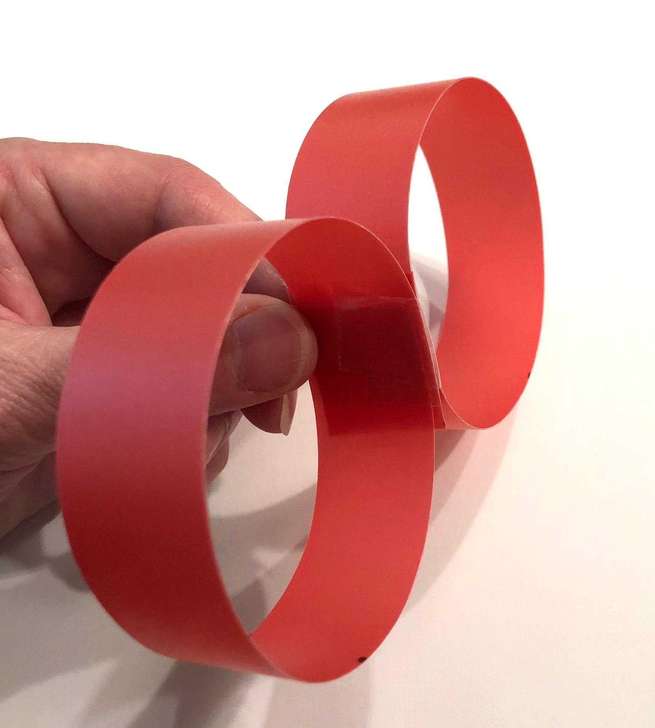  Demonstrate by taking the second of the rectangular strips (1” x 9.25”) of material cut from a plastic folder cover, and bending it into a circle and then taping both ends of it together. Then tape this circle against the first circle you previously made.  Ask students which materials have a repeating pattern in their microscopic structure like the one we just built, even if the exact shape and size of the air pockets in the structure might be slightly different. Students will say it represents most of the materials, except maybe for the cotton ballor Styrofoam. In the case of the Styrofoam students may say that the ratio of solid material to air or empty space isn’t right and that to represent Styrofoam, we need more solid and less air between the repeating structures. Say, We’ve made an argument here that this larger-scale structure represents something important we are seeing in the small and microscopic structures of many of these top force-reduction materials. They all have a large amount of air or space gaps in between the solid matter, just like this structure does. Now that we have analyzed a large-scale physical model that represents this important aspect of the structure of peak force reducers, we could use it to understand what might be happening at a much smaller scale within those small and microscopic structures of our top force-reducing materials. This is something that engineers and scientists often do when they want to understand how something works at a scale that is too small to see. They develop larger-scale models and test how those work and use the results of these tests to better understand the unobservable changes occurring in those smaller structures.  Take apart the circles you made so you demonstrate taping them together for your next class. | ✱ SUPPORTING STUDENTS IN ENGAGING IN DEVELOPING AND USING MODELS  This is an important opportunity to help students see that another type of model that engineers develop in science is one that can be used to visualize what is happening at a scale too small to see. Here students are using a scaled-up model to visualize what happens with peak forces when using materials with air gaps or pockets. It also prepares students to think like an engineer by using multiple models to generate data to figure out how part of a system works in order to know how to apply the design and optimization of a solution necessary to address an identified problem.
  Suggested prompt | Sample student response
  What does the structure of bubble wrap look like if we examined a cut-away section of it? | Thin, solid sheets of material that form a surface that is sealed up to form closed air pockets.
  What does the structure of a cotton ball look like if we examined a cut-away section of it? | Thin and long fibers that are wound together and that have open space between them.
  What does the structure of corrugated cardboard look like if we examined a cut-away section of it? | Wavy ripples of paper with a flat layer of paper between them and with arches or gaps between the ripples.
  What does the structure of a foam earplug look like if we examined a cut-away section of it? | Different-size open spaces surrounded by squishy material.
  What does the structure of Styrofoam look like if we examined a cut-away section of it? | Small, lightweight spheres or polygons with air pockets between them.
  ADDITIONAL GUIDANCE | Drawing a 2-dimensional, cross-section representation of the structure for each of the materials will help foreground the similarities between them that might not be apparent from a photograph that also shows some of the three-dimensional structure of the material, like in the bubble wrap or cotton ball.  Remember, between classes you will remove the half sheets of paper you added to this poster so that you can reuse the poster for all classes. Keep the final class’s representations posted in the classroom as an anchor chart for students to refer to in the remaining lessons of the unit.

3 · PREDICT OUTCOMES AND PLAN FOR DATA COLLECTION | 4 min
MATERIALS: half-sheet data table from Observations from Adding Additional Ring Structures, science notebook
Show slide C. Use this to cue students to turn and talk about the following questions:
- Would adding ring structures to the system, as shown in B and C, affect the peak forces in the collision? Why or why not?
- Would attaching these structures to the stationary object (brick), as shown in D and E, instead of to the moving object affect the peak forces in a collision? Why or why not?

Listen for different predictions in the partner talk.

Prepare to record data. Pull students together. Share that you heard different predictions in the partner discussions and suggest that we should try to collect some observations to see which of these predictions are supported or refuted.Distribute a half-sheet data table from Observations from Adding Additional Ring Structures to each student and have them add it to their notebook.

4 · RECORD AND ANALYZE DATA FROM SLOW-MOTION VIDEOS | 10 min
MATERIALS: science notebook, Observations from Adding Additional Ring Structures, computer, projector, https://youtu.be/co5fN22N50A, https://youtu.be/OU0LsRFmBnk, https://youtu.be/3A1gKY2qK1U, https://youtu.be/eqKLBJFZlnE, https://youtu.be/nqaDgidCHOM
Show slide D. Say, Let’s start by watching the first two conditions outlined in our data table.

Show video A: https://youtu.be/co5fN22N50A. Give students a minute to record their observations.

Show video B: https://youtu.be/OU0LsRFmBnk. Give students a minute to record their observations.

Before showing any other videos, discuss what students noticed to motivate watching these first two videos a second time with the goal of recording data that would allow us to determine the total length of collision time in each condition.

Suggested prompt | Sample student response
What did you notice about the peak forces in the two collisions? | There was less peak force in the system with a ring in it than in the system without a ring.
Since our very first lesson, we’ve been trying to visualize what was happening right at the moment of first contact to a split second after this happens. What did you see happening to the ring structure during the time the collision was occurring? | The ring was deforming and then after it reached a maximum amount of deformation it started returning to its original shape, which is when the cart started moving backward.
Were there any differences you noticed in the amount of time it took for the collision, either in terms of how long the objects were in contact with each other or in terms of how long it took for the collision to produce its peak forces? | It seemed like the system with a ring in it took longer than in the system with none.
What evidence could we collect from the videos to see if there is a difference in the amount of time those things took? | We could record the times we see on the phone or stopwatch running in the video when the contact first occurs and when it reaches peak force and/or when contact is broken off.

Say, Let’s watch these two videos again and record additional observations regarding the amount of time the collision took. You decide if you want to record how long it took to reach peak force after first contact occurred or if you want to record how long it took until the contact between the objects ends. Either way you will have to record at least two times. That will allow you to calculate and compare the length of time these events took in different collision conditions.

Ask students to stand in a semi-circle around the screen you are projecting the videos on before showing the videos again. Students can ask you to pause the videos at any time so they can take a closer look. Encourage students to go up to the screen and point to things in the video when they ask you to pause it. Students are likely to ask you to pause at each of these points in time:
- The point of first contact between the leading edge of the cart system and the leading edge of the brick system.
- The point where the peak force is reached
- The point at which contact is broken between the ring on the brick and the cart subsystem

Show videos A and B again.
- video A: https://youtu.be/co5fN22N50A
- video B: https://youtu.be/OU0LsRFmBnk

Then show videos C, D, and E.
- video C: https://youtu.be/3A1gKY2qK1U
- video D: https://youtu.be/eqKLBJFZlnE
- video E: https://youtu.be/nqaDgidCHOM

5 · ANALYZE AND INTERPRET THE DATA FROM THE VIDEOS | 10 min
MATERIALS: science notebook
Facilitate a discussion of the patterns across the five collision cases. Have students return to their seats. Show slide E. Cue students to read through the questions on their own and study the data table for a minute independently. Then discuss the questions on the slide as a whole group.

Suggested prompt | Sample student response
What patterns did you notice in the peak forces produced across all five collision conditions? | The peak forces decreased with more rings.  Two rings produced less peak force than one ring, which produced less peak force than no rings.  The amount of peak force was reduced just as much, regardless of whether the rings were on the stationary object or the moving object.
How did the motion of the cart system change after the system reached the point at which peak forces occurred? | The direction of the cart system reversed its motion.  It started moving in the opposite direction
What patterns did you notice in the total time it took to reach that point in the collision? | The total time the objects were in contact with each other increased as you added more rings.
Was there a similar pattern in the total time it took for the collision from when contact was first made to when the contact was broken? | Yes.

ADDITIONAL GUIDANCE | Some students may also notice that the maximum amount that every structure in the system deformed decreased when the system went from having 1 ring to 2 rings in it. If they notice that now, make note of it too, but don’t dwell on it yet. You will return to look for evidence of this on day 2 of this lesson when you develop free body diagrams of these structures for each of these conditions.

KEY IDEAS | Listen for the following key ideas in this next part of the discussion. When students share them, ask others to restate each of them.  - Structures like rings provide space for the protective material to deform.  - The more of these structures there are in a cushioner, the longer the contact time during the collision.  - The more of these there are in a cushioner, the lower the peak forces that are produced by the collision.  - When weaker forces are applied to an object it will take more time to change its motion.  - When stronger forces are applied to an object it will take less time to change its motion.

First focus on asking students to summarize the relationships they discovered among the number of structures that have space in them to deform, the length of time the deformation is occurring over, and the peak forces produced in the collision.

Suggested prompt | Sample student response
What can we conclude will happen to the peak force in a collision then when we add more structures that have gaps, space, or air pockets in them in between the two colliding objects? | The peak forces on things in the system will go down.
What can we conclude will happen to the amount of time the collision takes when we add more structures that have gaps, space, or air pockets in them in between two colliding objects? | The total time the objects were in contact with each other during the collision from the start of collision to end will increase.

Now shift to asking students to generalize the relationship between the strength of force applied to an object and the time it takes to change the motion of the object.

Suggested prompt | Sample student response
In every case the motion of the cart changed in the collision. It went from moving in one direction to moving in the reverse direction. Let’s try to summarize what this tells us about the relationship between the time it takes to change the motion of an object and the strength of forces used to do it. So when weaker forces are applied to an object to change its motion, what will happen to the amount of time it will take to do that? | It will take a longer amount of time.
When stronger forces are applied to an object to change its motion, what will happen to the amount of time it will take to do that? | It will take a shorter amount of time.

6 · INDIVIDUAL PROGRESS TRACKER | 5 min
MATERIALS: science notebook
Update individual Progress Tackers. Say, These ideas are all based on observing these large-scale structures. But let’s remind ourselves that these weren’t the specific structures we were interested in explaining at the start of our lesson. We were initially interested in explaining how and why the microscopic structure of an effective cushioning material decreases the peak forces in a collision. Let’s take a moment to think about how we apply what we figured out to those materials.

Show slide F. Give students the remaining time to add an entry to their individual Progress Trackers in their science notebook related to the lesson question:
- How (and why) does the structure of a cushioning material affect the peak forces produced in a collision?

Ask students to leave their notebooks for you to review before the next class.

ASSESSMENT OPPORTUNITY | Building towards: 13.A Construct an explanation for how (and why) the structure of a cushioning material affects the peak forces produced (function) in a collision, relating the amount of space available for deformation, the total contact time during a collision, and the peak forces produced from the addition of such structures.  What to look for  - Good cushioning (force-reduction) materials have space available in them for deformation.  - More space available for deformation is related to an increased contact time during the collision.  - Increases in contact time in the collision is related to decreased peak forces produced in the collision.  - Optional: Students may argue that thicker cushioning materials with spaces or air gaps in them available for deforming should therefore reduce peak forces more in a collision.  What to do: The individual Progress Tracker is designed to be a space for students to make sense of what they have figured out, and therefore these individual entries may or may not be shared with and reviewed by the teacher at different points in the unit. For this specific entry, use what students have entered individually as a formative assessment piece that is not scored but instead is used to ensure students are ready to move on the next day. At the end of this lesson, the class will co-construct a three-box Progress Tracker to record what the class has come to consensus on about what they have figured out about cushioners. At that point, students may turn to this entry and use what they have recorded here as they help the class co-construct. Because this entry serves as a formative assessment piece, you may choose to just read through them to gauge where students are at and/or, for those that might benefit from thinking more about the question, you could leave question prompts as feedback directly in their notebook on this entry.

End of day 1

7 · DEVELOP AND USE FREE BODY DIAGRAMS | 20 min
MATERIALS: Free body diagrams for collisions with and without cushioning structures, 2 colored pencils (any color), Consensus model from Lesson 5 with the free body diagram on it, chart paper, markers
Say, At the end of our last class you summarized what you figured out about how and why the structure of a cushioning material affects the peak forces produced in a collision. Let’s use what you figured out to think about what is happening to each structure in the system from a free body diagram perspective and then use that form of system thinking to make predictions about what would happen when we change the structure of the materials we are using in other ways. Show slide G.

Distribute Free body diagrams for collisions with and without cushioning structures to each student and have them add it to their notebook.

Gather students in a Scientists Circle. Bring the Consensus model from Lesson 5 with the free body diagram on it to the circle.

KEY IDEAS | Purpose of this discussion: Help students apply use of free body diagrams for representing the forces in subsystems in Lesson 5 to the subsystems from the most recent investigation.  These representations include showing external forces on each subsystem as in the following:  - The direction of the force arrow indicates the direction of the force applied on the object.  - Differences in length of an arrow represent differences in the relative magnitude of a force.  - The tip of the arrow indicates the surface on which the contact force pushes.

Ask students to compare the objects and subsystems represented for each of the conditions shown in the system diagrams on the handout and describe what is simplified in these representations.

Suggested prompt | Sample student response
Look at the chart on your handout. These are simplified diagrams showing the different structures that were added between the cart subsystem and the brick in the videos we analyzed. What is different in each diagram that shows this? | A ring is added in one. And two rings are added in the other.
Though the rings and brick have a similar shape to what we saw in the video, notice that the cart and spring-scale subsystem has been simplified to show the cart and the spring scale. What are some parts of the cart subsystem that are left out of this diagram? | The wheels.
In addition to the wheels, what are other things the wheels make contact with that are also left out of the diagram? | The track.
So in the first diagram, we see only two subsystems being represented. How many clearly labeled subsystems are there in the next diagram? | Three.
And in the third diagram? | Four.

Introduce another modeling convention in free body diagrams. Say, These sorts of simplifications, leaving out some details and objects and paying attention to a subset of them in a system, are commonly done when engineers or scientists make free body diagrams of moving objects. Many times the objects in the system are simply shown as rectangles or circles rather than including other details that don’t necessarily help visualize where the force interactions are occurring in the system.

Connect to other examples of simplified representations of objects and interactions from work students have done in prior OpenSciEd units. Say, When this sort of simplified representation is used, however, it's important to label each object in the system that you are developing a free body diagram for. You’ve made similar simplifications for other system models you’ve developed in other units. For example, in your work on Palm Oil Unit when modeling interactions in the palm oil and native ecosystems for orangutans, what are some of the populations of organisms in the ecosystem that you showed interactions between with just a simple rectangle? Students will say things like orangutans, palm oil trees, fruit trees, insects, tigers, rats, and pigs as just a few examples.

Co-develop free body diagrams for the two subsystems in the ringless collision. Use the following prompts to elicit students' ideas to add to the creation of two free body diagrams for this condition on a piece of blank chart paper.

Suggested prompt | Sample student response
How many separate free body diagrams should we draw for the first collision case? | Two.
Is one object applying a force on another object without the other object applying a force back? | No.
And how should the strength of the forces on each object compare? | They should be the same.
How do we represent that the forces on each object are equally strong? | Use arrows of equal length.

The completed free body diagram should look something like the illustration in the right column shown here. Students should add something similar to the first row in their table on Free body diagrams for collisions with and without cushioning structures.

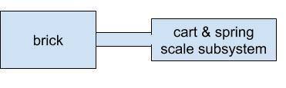 |  | 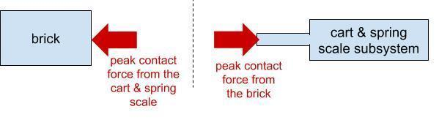
Co-develop free body diagrams for the three subsystems in the single-ring collision. Use the following prompts to elicit students' ideas to create three free body diagrams for this condition on the chart paper below the first free body diagrams.

Suggested prompt | Sample student response
Let’s treat the cushioner, or the ring, as a single subsystem with its own free body diagram. If we do, then how many total separate free body diagrams should we draw for the second collision case? | Three.
OK, let’s draw each of those and label them. And let’s start with the cart and spring-scale subsystem. Which subsystem is making direct contact with the tip of the spring-scale plunger when it registers a peak force? | The ring.
Which way is the ring pushing on the tip of the spring-scale plunger? | It is pushing on it with a force pointed to the right.
How should the strength of this force compare to what we showed in the diagram above? | There should be less peak force.
How would we represent this in our diagram? | We should show this with a smaller length for an arrow.
Does the spring-scale launcher tip push back on the ring? | Yes.
In what direction and with how much force? The same amount as we showed on the spring-scale plunger? More? Less? | The opposite direction with just as much force as we showed on the cart and spring-scale subsystem (which is less than in the first diagram).
OK, that is one force arrow we have added to the ring now. But what else does the ring make contact with when the system reaches peak forces? | It makes contact with the brick.
And we know that the ring pushes back just as much on the things that compress it, whether it is attached to the motionless thing or to the previously moving thing. So how would the amount of force that the ring is pushing back on the brick here compare to how much the ring was pushing back on the cart? | It should be an equal amount of force.
So is that amount of force between the brick and the ring only on the brick or only on the ring, or is it on both? | Both.

The completed free body diagram should look something like the illustration in the right column shown here. Students should add something similar to the second row in their table on Free body diagrams for collisions with and without cushioning structures.

 | 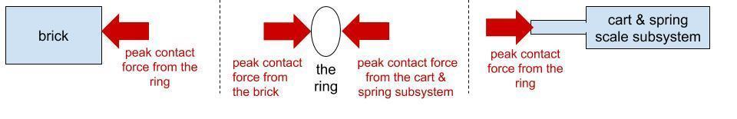
  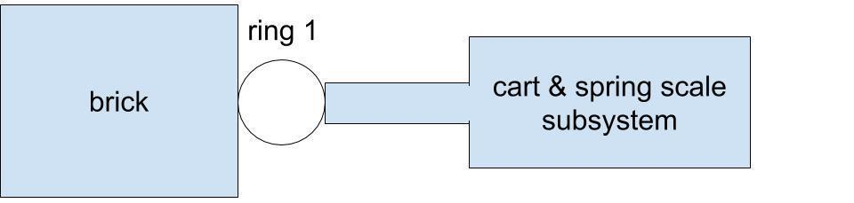

Introduce two different ways to model the two-ring condition. Say, For the two-ring condition, you could choose to represent the two rings as a single subsystem or you could represent them as two separate subsystems. In the first case you would need to show three free body diagrams, while in the latter you would need to show four. You and your partner should decide how you want to model that condition, but remember to look back at our results from the video so that your model accurately represents the relative strength of all the peak contact forces from the interactions between each subsystem in your model.

Give students 5 minutes with an elbow partner to complete the third row in the handout. Emphasize that this is one part of a formative assessment you want to collect.

After students have completed the third row, ask if there are any questions and if students feel confident they could use this way of representing forces in each subsystem to predict what would happen if there were three rings of the same size chained together on either the spring scale or the brick.

8 · USE FREE BODY DIAGRAM MODELS TO MAKE PREDICTIONS | 6 min
MATERIALS: Free body diagrams for collisions with and without cushioning structures
Show slide H. Have students return to their seat to complete Free body diagrams for collisions with and without cushioning structures. Emphasize that this is the second part of the formative assessment you want to collect. Collect Free body diagrams for collisions with and without cushioning structures when students have completed their work.

ASSESSMENT OPPORTUNITY | Building towards: 13.B Develop and use subsystem models (free body diagrams) to represent how the peak contact forces on different objects in a collision compare when they have different cushioning structures between them.  What to look for: Look for a system model that includes the following structures and subsystems:  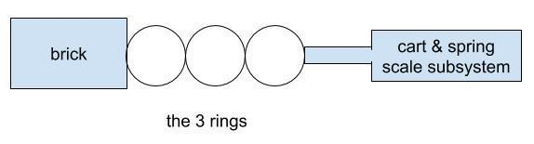  Look for free body diagrams. In every approach used, the length of the force arrows should be shorter than any previous condition. One approach would be to treat the three-ring cushioner as a single subsystem. If so, look for the following in student responses.  Another approach would be to treat the three-ring cushioner as three separate subsystems. If so, look for the following in student responses.  What to do: For students who struggle with creating these free body diagrams, pair them up with another student who has been finding success with developing these diagrams and ask them to compare their models using the "partner feedback process" from slides D and E they used in lesson 10. This will provide a structured way for each student to share their diagram, compare each other’s diagrams, ask questions, and then revise their models.
  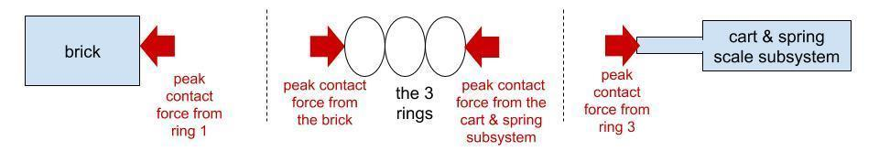
  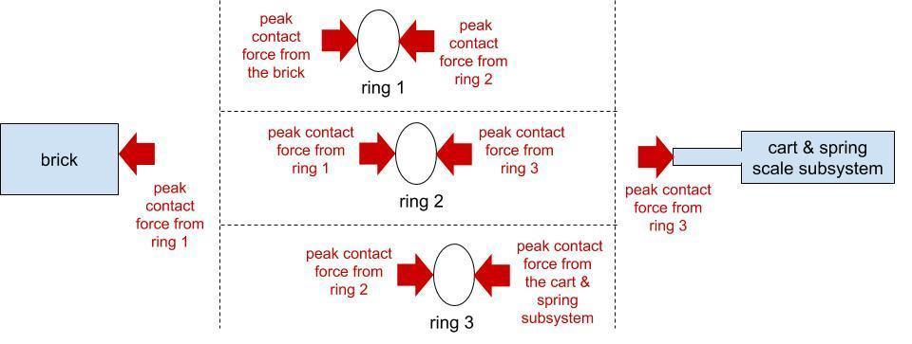

9 · SIZE PREDICTIONS | 4 min
MATERIALS: Free body diagrams for collisions with and without cushioning structures
Introduce the context for another shape consideration. Show slide I. Read the text at the top of the slide, Some design solutions for protective devices may have criteria or constraints that impose a limit to the amount of space available for adding cushioning material to a system. Let’s consider a system where there is a limited amount of total space available for adding cushioning material to it. Ask students to discuss the questions on a slide with a partner for a couple minutes.

Then discuss these questions briefly as a class.

Suggested prompt | Sample student response
If we wanted to double the number of air gaps or spaces in the structure of a cushioning material used in the space, how would the size of those air gaps or spaces have to change in order to fit them in? | They would have to get smaller.  They would have to shrink.
Do you think that change would also affect the reduction in peak forces that those structures provided in a collision? | (Accept all predictions.)

10 · ANALYZE SIZE DATA AND UPDATE PROGRESS TRACKER | 7 min
MATERIALS: science notebook
Introduce size data. Show slide J. Give students the remaining time to discuss the data on this slide with a partner and to add to their Progress Tracker (while still talking with a partner) under the entry for this question:
- How (and why) does the structure of a cushioning material affect the peak forces produced in a collision?

11 · NAVIGATION | 3 min
MATERIALS: None
Make initial predictions about changes to the structure or shape of a cushioning material and the related effect on peak forces in collision. Show slide K. Emphasize that students should discuss this question with a partner now so that we can share what ideas partners came up with as a whole class next time:
- Do you think other changes to the structure or shape of a cushioning material would affect how much it reduces peak forces in a collision? Why or why not?

End of day 2

12 · NAVIGATION | 3 min
MATERIALS: None
Share predictions from the end of last class. Show slide L. Discuss this question as a whole class, getting a few different reasons for the predictions that students made. Accept all responses.
- Did you and your partner think that other changes to the structure or shape of a cushioning material would affect how much it reduces peak forces in a collision? Why or why not?

13 · INTRODUCE A CONTROL CONDITION AND MAKE PREDICTIONS | 5 min
MATERIALS: Other Shape Tests, Exploring shape of a cushioning material, science notebook
Say, Since we have some different predictions about the impact that other shape changes in a cushioning material will make in a collision, let’s collect some additional data on this question. Let’s test five different structures where we again use rings as a repeating substructure across each structure we test. These are the structures we are going to test.

Show students the 5 structures we will be testing. Ask students to describe the relative size and arrangement of the rings in each structure. Students will say that they are the same size and many are taped together.

Motivate testing a control. Say, For each of these structures let’s place them between a plate and the table and apply the same amount of force on the system and see how each structure will respond. Before we test all of these structures, let’s take some initial observations for one of the structures to serve as a control condition and then use this to make some predictions about how the rest of the structures will function in comparison to that.

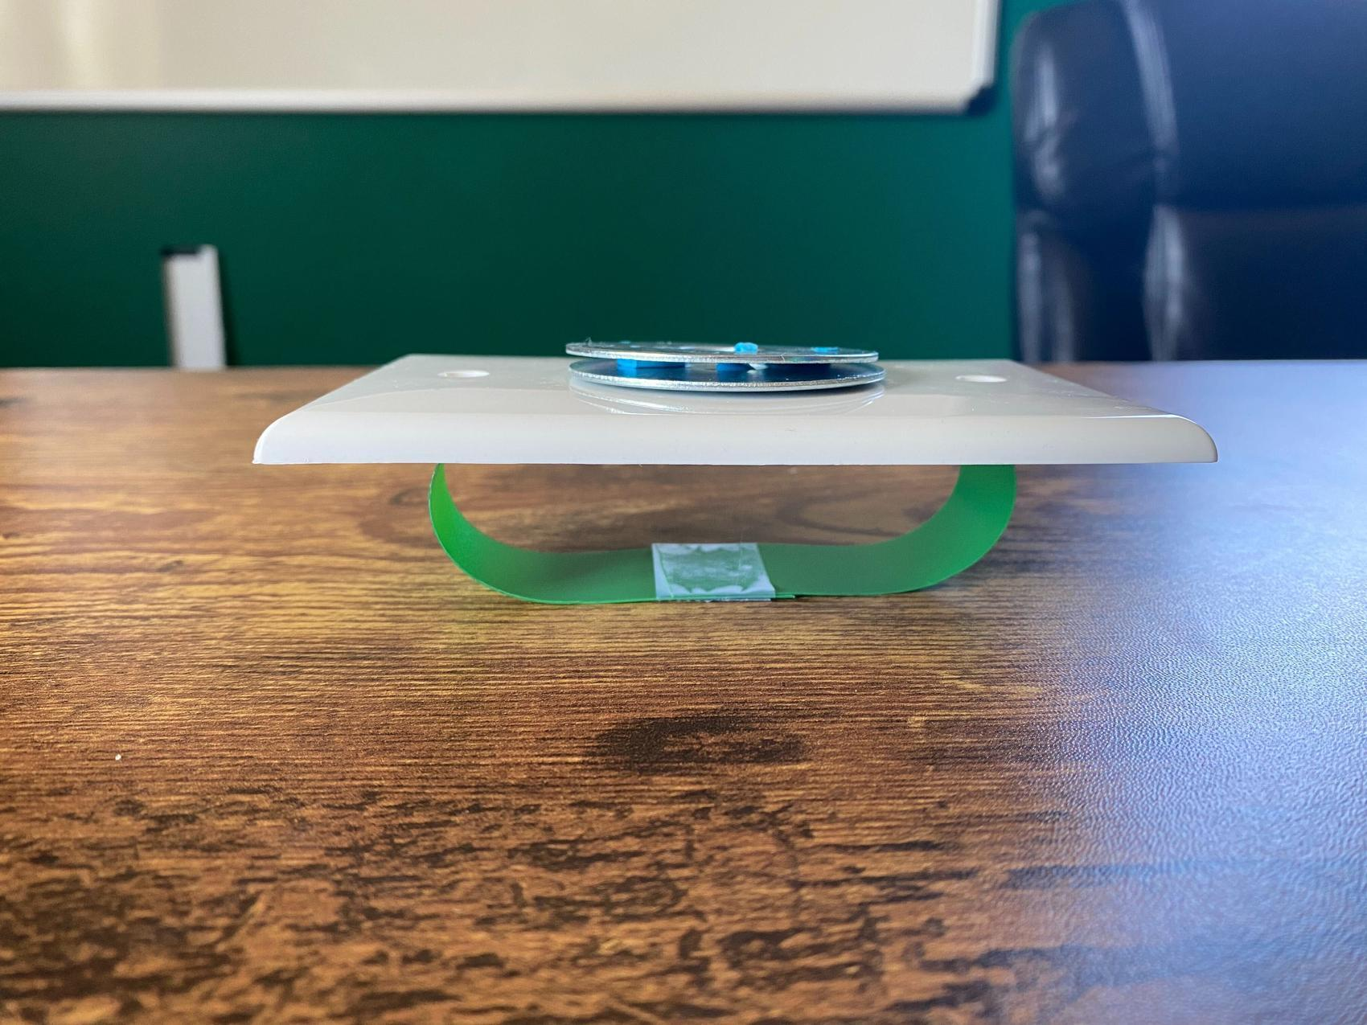
Demonstrate the single-ring condition by placing one of the weighted electrical plates on it. Use the sticky putty on the back side of the plate to secure the ring to the bottom of it. Now, on the table, balance the weighted plate on top of the ring. Describe how you are trying to balance the plate on the ring without pushing down or lifting up more on the system to do so. Ask students to describe what they notice happening. They will say the ring deformed.

Remove the weighted plate. Say, I massed each plate before class and adjusted the amount of putty on each so that they all have the same weight. We can therefore use these to apply the same amount of force to these four other structures. Optional: Demonstrate this for a couple of plates by placing them on a digital scale, if needed.

Distribute Exploring shape of a cushioning material. Ask students to think about how the other structures will compare when we apply the same amount of weight on top of the plate but change the number of rings in between the plate and the table and record their predictions on the new handout you are giving them. Show slide M. Give students a couple of minutes to record their predictions on the handout.

14 · TEST THE FIRST THREE STRUCTURES | 10 min
MATERIALS: Other Shape Tests, Exploring shape of a cushioning material, science notebook
Gather around a demonstration area. Have 3 students help balance the weighted plate on top of the first three structures (1 ring, 2 rings side by side horizontally oriented, and 3 rings side by side horizontally oriented) . Ask for student volunteers to help do this. Have the rest of the class gather around the demonstration area. Student volunteers should balance their weight on top of these structures, keeping it from tipping over but trying not to lift or push down on it any, just like you demonstrated. After doing this long enough for other students to record their observations (e.g., 2 minutes), ask another set of 3 volunteers to swap places with the first 3 students so that they can record observations as well.

Discuss the patterns they noticed as a class.

Suggested prompt | Sample student response
What did you notice happening among the one-ring, two-ring, and three-ring structures? | The more rings, the less they deformed.
What does this tell you about the amount of force on each ring when there are two or three rings compared with when there is one ring? | It is less.
How much less force would there be on each ring when there are two rings instead of one? | Half.
How much less force would there be on each ring when there are three rings instead of one? | A third.

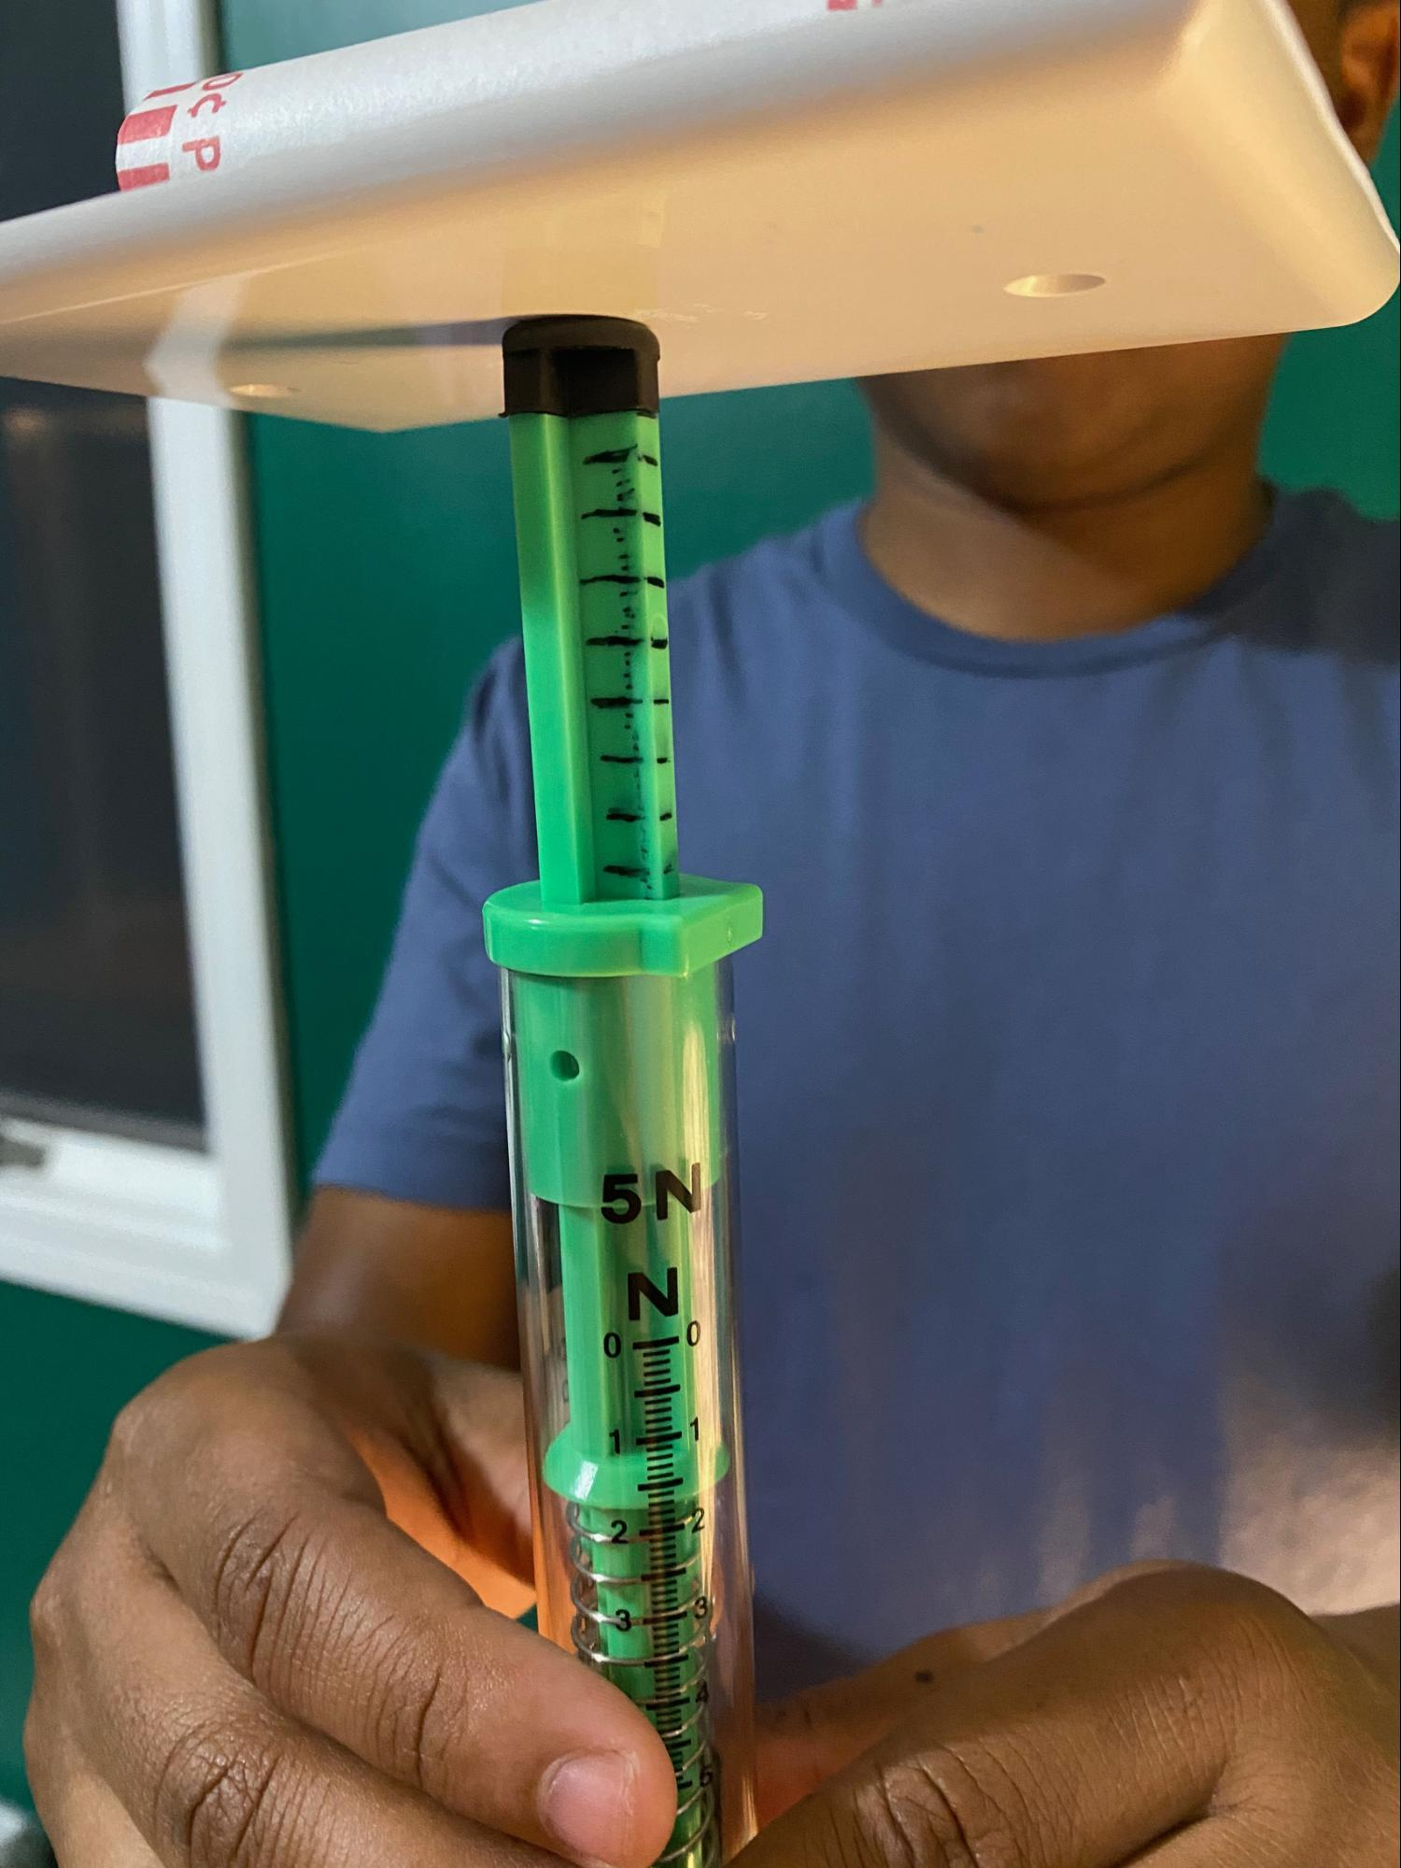
Say, Let’s use our push-pull spring scales to test this. Let’s swap in a spring scale for a ring, since we know that the rings and the springs are both behaving elastically, and see how much force is registered on each spring scale. Ask for a student volunteer to record the results on the board for each condition tested (using 1 spring scale to support the weight, using 2 spring scales to support the weight, using 3 spring scales to support the weight).

Ask for student volunteers to help hold and test the first condition. It will take at least two people to balance a weighted plate on top of a push-pull spring scale held upright. A third person can read the amount of force registered on the scale.

Do this again for two spring scales held upright under the weighted plate. This may take another person to do.

Do this again for three spring scales held upright under the weighted plate. This may take another person to do.

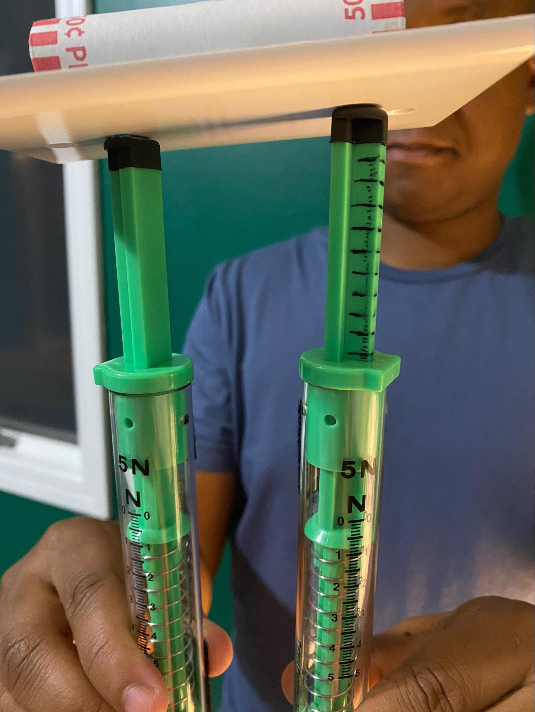
Give a minute for students to record their observations on their handout.

ADDITIONAL GUIDANCE | If one spring scale of the two or three used is slightly higher than the others when measurements are taken, one side of the scales may register a higher force reading than the others, but the sum total of all the forces on 2 or 3 springs scales should still add up to the total amount from the single scale test condition.

Suggested prompt | Sample student response
How did these measurements compare to our predictions? | This is what we predicted would happen.
So if a collision occurred on the surface of the plate and it produced a certain amount of peak force where contact was made, how strong would the forces be below each point of contact on a three-ring structure like this. | One-third.
So if we could use ten rings instead of one, how much force would there be on each ring and the structure below it? | One-tenth.

Say, How would this affect the amount of damage on an easily deformable object placed below it? Students should say that it should reduce the amount of damage on it

Place a sheet of Styrofoam on the table and under a spring scale with the plunger touching the Styrofoam. Stack all three of the weighted plates on top of the spring scale. This will make an indentation on the Styrofoam. With a fine-tip permanent marker trace the outline of where the spring-scale plunger touches the Styrofoam before removing it.

Move to an undamaged spot on the Styrofoam. Hold three spring scales together with their plungers touching the Styrofoam and place the stack of three weighted plates on top of them so all three scales are holding up the stack of plates. Trace the outline of where all three spring-scale plungers touch the Styrofoam before removing them.

Hold up or pass around the Styrofoam and ask students to describe what they notice. Students will say that there is more damage from the single spring scale than from the three.

Say, This three-spring-scale structure provides more points of contact to push back. Because of that, the amount of contact force at each point of contact is less. In a way, we can think of the structure as spreading out the force it is pushing back with across a larger surface area. And from the Styrofoam we can see that this has an effect on the damage on a material it is in contact with. So we can see that it's not just how much peak force is applied to a material that causes it to be damaged. It’s really how much peak force is being applied at a particular spot on the material. So if you can spread the amount of force being applied to more spots or over a greater area, this should result in less damage to the object those forces are being applied to. Let’s see if we can use these ideas to explain what our six-ring, triangular structures do when a force is applied to them.

15 · TEST THE LAST TWO STRUCTURES | 5 min
MATERIALS: Other Shape Tests, science notebook, Exploring shape of a cushioning material
Carry out the last two structure tests in the demonstration area. Prepare to test the last two structures (6- ring, triangular shape). Ask for student volunteers to help do this. Student volunteers should balance their weight on top of the last two structures (6-ring, triangular shape). Ask for student volunteers to help do this. . Student volunteers should balance their weight on top of the structures, keeping it from tipping over but trying not to lift or push down on it any, just like you demonstrated. After doing this for a minute as other students record their observations, ask for 2 other volunteers to swap places with the first volunteers so that they can record observations as well.

Briefly discuss what students notice.

Suggested prompt | Sample student response
Which rings deformed less than others? | The row of three rings deformed less than the row of two rings which deformed less than one ring.
In each case, which objects are experiencing the strongest forces where a ring is touching, the weighted plate or the table below it? | It depends. When the point of the triangle is touching the weighted plate, there would be stronger forces there than along the base of the triangle against the table. But when the point of the triangle is touching the table, there would be stronger forces there than along the base of the triangle against the weighted plate.
So if we decided to use one of these cushioning structures to protect a collision between a falling weighted plate and the table, which of these structures would be more effective at protecting the table below it? Which would be more effective at protecting the plate above it? | The wider part, the three rings, of the triangle should be against the surface you want to protect.

16 · PROGRESS TRACKER UPDATE | 18 min
MATERIALS: science notebook, chart paper, markers
Say, Let’s summarize all of these discoveries in a Progress Tracker update as a class. Show slide N. Have students prepare a 3 column entry in their Progress Tracker. You will fill in this entry together as a class.

Gather students in a Scientists Circle. Hang a piece of chart paper. Layout a table for a whole class progress tracker entry as shown on slide N. Remind students that we’ve been working as a class on the same question about structure as the one they wrote in their Progress Tracker last time. Ask them to look back to see what that question was. Write it on the chart paper in the “Question” box and have students add it to their ”Question” section for this new Progress Tracker entry.

Then ask students, In the last lesson, what sort of testing and inspecting did we do with different cushioning materials before we started working with rings and what did we figured out from those. Students will say in the last lesson we did a series of collision investigations to determine which reduced forces the most and inspected those materials up close.

Ask students how we figured out that the top cushioners had similar structures in terms of a lot of empty space or air within their materials to deform into. Students will say we looked at up-close and microscopic photographs of cutaways of the materials.

Add to the Progress Tracker chart paper so that it reflects these ideas. Students should add similar information to their Progress Tracker entry. It should now have something like this in it:

Lesson question | Source of evidence
How (and why) does the structure of a cushioning material affect the peak forces produced in a collision? | - Peak force collision tests with different materials  - Up-close and microscopic photographs of top performing materials
What we figured out
- Protective materials tend to have a lot of space (or air) for the solid materials to deform into, which makes these materials relatively easy to deform (with little force applied to them).

Ask students why we started to use rings to explore the behavior of these structures further and what we figured out at first from our increasing the space in a cushioning material through the ring collision videos.

Suggested prompt | Sample student response
Why did we start to use rings to explore the behavior of these structures further? What about the microscopic material structure did the rings represent? | The rings represented a common structural element in the materials, something that has a lot of space or air for the solid material to deform into.
How did adding more rings help us visualize the effects of adding more cushioning material? | It allowed us to see deformation occurring across the spaces within those materials.
How did increasing the space that the cushioning material could deform into affect the total time of the collision? What did adding more rings do to the total time the collision took? | It increased it.
And what did this do to the peak forces produced in the collision? | It reduced it.
So, then, what did we discover the relationship is between the amount of time a collision lasts and the strength of forces applied by a cushioner? | We can change the motion of an object with materials that apply weaker forces over more time instead of using materials that apply stronger forces over less time.

Emphasize that we also discovered that simply packing smaller and smaller spaces (or smaller rings) into a material and/or making the structure of that material more dense doesn’t necessarily help it reduce peak forces, and it actually may have the opposite effect.

Add to the Progress Tracker on the chart paper so that it reflects these ideas. Students should add similar information to their Progress Tracker entry. It should now have something like this in it:
Lesson question | Source of evidence
How (and why) does the structure of a cushioning material affect the peak forces produced in a collision? | - Peak force collision tests with different materials  - Up-close and microscopic photographs of top performing materials  - Scaled-up ring structures attached to spring-scale carts in collision videos
What we figured out
- Protective materials tend to have a lot of space (or air) for the solid materials to deform into, which makes these materials relatively easy to deform (with little force applied to them).
- The thicker these kinds of materials are, the more they reduce peak forces because this increases the total time the collision takes.
- Making a material more densely packed with smaller and smaller spaces does not necessarily reduce peak forces. Such increased density may actually have the opposite effect.

Ask students to summarize what we figured out from the most recent test we did of 5 different ring structures. Listen for ideas like these:
- The more you can spread the peak forces out over a larger area or over more points of contact, the less force is applied to each point of contact.
- This can reduce the amount of damage on the material you are trying to protect.

Add these ideas to the Progress Tracker on the chart paper. Students should add similar information to their Progress Tracker entry. It should now have something like this in it:
Lesson question | Source of evidence
How (and why) does the structure of a cushioning material affect the peak forces produced in a collision? | - Peak force collision tests with different materials  - Up-close and microscopic photographs of top performing materials  - Scaled-up ring structures attached to spring-scale carts in collision videos  - Testing of different-shaped structures with weights on top of them
What we figured out
- Protective materials tend to have a lot of space (or air) for the solid materials to deform into, which makes these materials relatively easy to deform (with little force applied to them).
- The thicker these kinds of materials are, the more they reduce peak forces because this increases the total time the collision takes.
- Making a material more densely packed with smaller and smaller spaces does not necessarily reduce peak forces. Such increased density may actually have the opposite effect.
- The more you can spread the peak forces out over a larger area or over more points of contact, the less force is applied to each point of contact; this can reduce the amount of damage on the object you are trying to protect

17 · NAVIGATION | 5 min
MATERIALS: Reading: Anatomy of a Bike Helmet
Connect to a prior sports-related phenomenon and the design problem students have been working on. Remind students that they have been considering their own design problem for a few lessons now and that earlier in the unit they had looked at how some sports have a risk of concussions due to head collisions. Ask students to consider how what we summarized what we have figured out could be applied to both of these contexts. Show slide O. Give students 3 minutes to discuss these questions with a partner.

Assign the home learning. Show slide P. Distribute Reading: Anatomy of a Bike Helmet. Emphasize that this reading will discuss the design of one type of protective headgear to prevent concussions related to collisions people can experience from riding a bike and that the information in the reading will include ideas that students will need to use on their assessment in a couple of days. Explain that assessment will come after they first revise their own designs and will involve evaluating protective headgear for preventing concussions in a different sport.

ASSESSMENT OPPORTUNITY | Building towards: 13.C Critically read a scientific text adapted for classroom use to determine how concussions can result in breaks in the axons of neurons (structure) and why this can lead to memory loss (function), how a snug fit (structure) for a helmet would affect its performance (function), and how other changes in the structure of cushioning material (in a helmet) would affect its performance (function).  What to look for: Use of structure-and-function relationships in the responses to the following questions:  - Question 1 and 2 should include the ideas that  - concussions can result in breaks in the axons of neurons (structure),  - new connections between neurons is how memories are stored, and  - breaking such structures would result in memory loss (function) which could tend to accumulate or get worse with each additional concussion.  - Question 3 should include the ideas that  - a snug fit increases the surface area or points of contact between a helmet and the head,  - this would spread out the forces applied to a larger section of the head,  - this would reduce the strength of peak forces on any particular section of the head in a collision, and  - this would improve its ability to protect the head from a concussion in a collision because the kinetic energy of the objects would be higher if there was not a snug fit.  - Questions 4 and 5 should include responses that  - cracks or dents in cushioning material change its physical structure and  - any changes in structure could affect how effectively it can reduce peak forces in a collision.  - Students may mention a variety of reasons why effectiveness of the cushioning material would be reduced, such as these:  - reducing how much it can deform,  - changing how springy it is (its force-to-deformation ratio),  - changing the elastic limit of the pieces that aren’t broken,  - or that the now-broken-up structure may no longer be able to spread out the force across a larger area,  - and, in the case of the dent, reducing the number of points of contact with the head, thereby increasing the amount of peak force on the remaining points of contact.  What to do: Review this after you collect it at the start of Lesson 14 and return it to students before you start Lesson 15. Provide guidance or feedback to students in time for them to use it to prepare for the Lesson 15 assessment that uses a related protective headgear design context.

ALTERNATE ACTIVITY | Extension: The Centers for Disease Control and Prevention (CDC) has extensive information for parents, teachers, coaches, and students about head injuries. These resources are available at https://www.cdc.gov/headsup/resources/index.html and include training courses, customizable materials, public service announcements, and podcasts.  Universal Design for Learning: To increase relevance for students, consider downloading and printing the following:  - concussion fact sheet for athletes: https://www.cdc.gov/headsup/pdfs/youthsports/factsheet_athletes_ages14-18-a.pdf  - Spanish language version: https://www.cdc.gov/headsup/pdfs/youthsports/esp/athletes_Span.pdf  - bike helmet safety fact sheet: https://www.cdc.gov/headsup/pdfs/helmets/HeadsUp_HelmetFactSheet_Bike_508.pdf  Students might also be interested in reviewing training materials, viewing the concussion-related videos, or listening to podcasts with their families.

